M-Tech Production & Marketing Technology | Training | Marketing | Projects

TASK REPORT
Internship Program — Batch 2026

Submitted By: Ali Sher Haideri
Department: Cyber Security

Submitted To: Malik Mohazin Zahid
Date: 5 July 2026

Lab Objective
The main objective of this task is to understand cloud security and study the risks of cloud misconfigurations. Specifically, this report focuses on:
- Learning the Shared-Responsibility Model to understand the division of security duties between cloud providers and customers.
- Analyzing Open-Bucket Leaks, how they accidentally happen, their dangerous impacts on sensitive data, and the best practices to prevent them.

Introduction to Cloud Security
Cloud computing means saving our data, files, and applications on the internet instead of our local computer’s hard drive. Many big companies like Google, Amazon, and Microsoft provide these cloud spaces. Cloud security is all about protecting this data from hackers and keeping it safe.
Many people think that once they put their data on the cloud, it is 100% the cloud company's job to protect it. But that is not true. Security in the cloud depends on both the company and the person using it. If we make mistakes in settings, our data can become public.

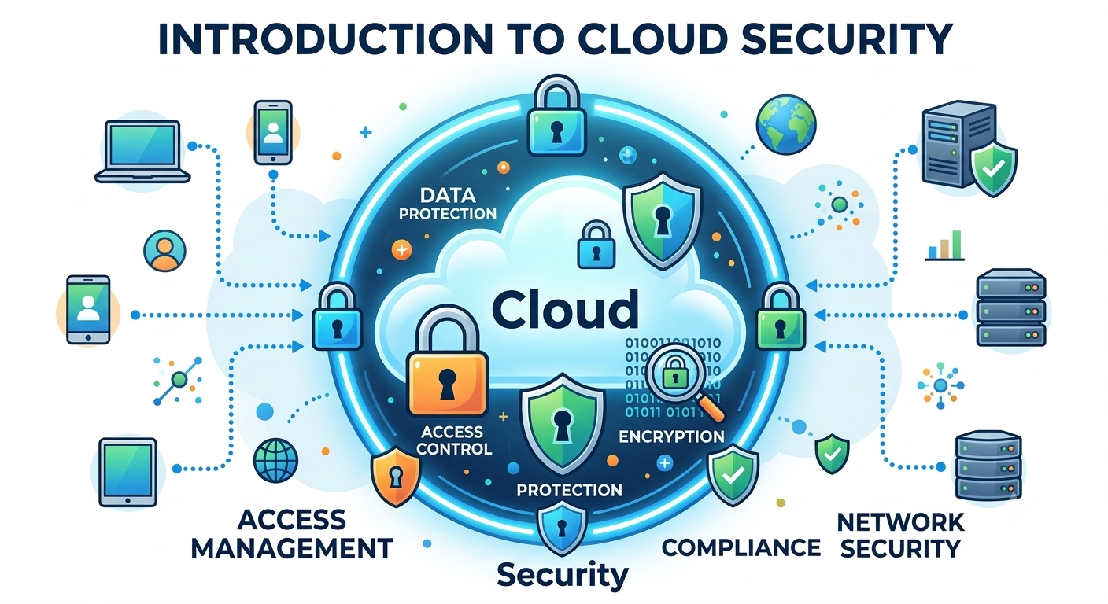

The Shared-Responsibility Model
To understand cloud security, we must understand the Shared-Responsibility Model. In simple words, it means that security is a teamwork between the Cloud Provider (like Amazon AWS or Google Cloud) and the Customer (us).
We can understand this with a simple example of renting a house:
- Responsibility of the Landlord (Cloud Provider): The owner of the house is responsible for making strong walls, a solid roof, and a secure main gate. In the cloud, the provider protects the physical servers, hardware, routers, and the actual building where the data centers are located. They make sure the physical infrastructure is secure.
- Responsibility of the Tenant (Customer): The person who rents the house is responsible for locking their own room's door, keeping their keys safe, and not letting strangers inside. In the cloud, the customer is responsible for setting strong passwords, managing who can access the data, and configuring the settings correctly.
If the cloud provider's server breaks down, it is their fault. But if a customer leaves their data folder completely open without a password, it is the customer's fault.

What are Open-Bucket Leaks?
In cloud platforms like Amazon AWS, data is stored inside folders which are called "Buckets". By default, when we create a bucket, it is "Private" so that only the owner can see the files.
An Open-Bucket Leak happens when a user or developer accidentally changes the setting of a bucket from "Private" to "Public". It is like leaving the front door of your house wide open while you are away.
When a bucket is left open, anyone on the internet who finds the link can see, download, or even delete the files inside it. Hackers use special automated tools to search the internet for these open buckets. If a company leaves sensitive data like user passwords, credit card numbers, or personal photos in an open bucket, it leads to a huge data breach.
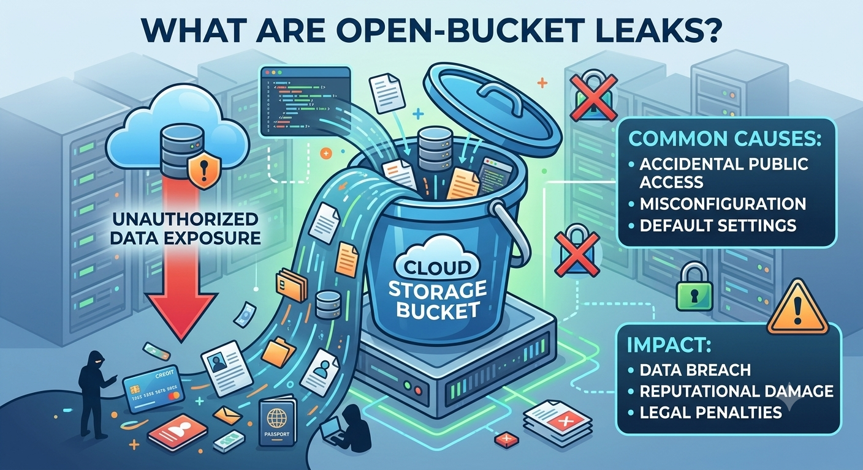

How to Prevent Open-Bucket Leaks
We can protect our cloud data from these leaks by following some simple steps:
- Keep it Private by Default: Always make sure that new buckets are set to private. Only change it if it is absolutely necessary.
- Turn on "Block Public Access": Cloud providers now have a special button that blocks all public access to buckets completely. We should always keep this turned on.
- Regular Audits: We should check our cloud storage settings every week or month to ensure no folder was made public by mistake.
- Use Access Management: Give access permissions only to those people who really need it to do their job (Principle of Least Privilege).

Conclusion
Cloud security is not difficult, but it requires us to be careful. The Shared-Responsibility Model shows us that we cannot blame the cloud provider for our own mistakes. Open-bucket leaks are a major security risk, but they can be easily stopped if we just pay attention to our privacy settings and follow basic cyber security rules.

